Capital Inter-District Soccer League
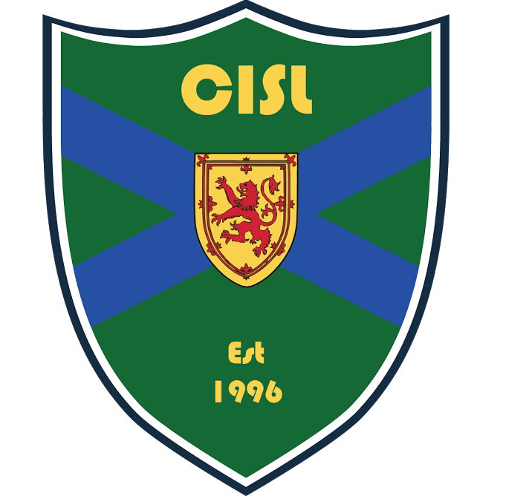

For those who are interested in participating in the Jamboree or Challenge Cup please fill out the registration form and send it to CISL. There is no fee to register. However, we are looking for donations of backpacks to support the Backpacks for Kids program for the Salvation Army. These backpacks can be dropped off any time after June 15, 2017 at the CISL office in the BMO Soccer Centre. Good luck and have fun!
Registration Form
Team (Club + Age + Gender + Division):
Contact Person:
Phone: Email:
PLEASE REGISTER BY JULY 31st, 2017 FOR CHALLENGE CUP
- Challenge Cup: U13B, U15B, U17B

- I understand that my team is responsible to pay half the fees for all officials in this tournament (split with the opposing team)

PLEASE REGISTER BY JULY 31st, 2017 FOR JAMBOREE
- Jamboree: U9, U10, U11, U12

- I understand that my team is responsible to pay half the fees for all officials in this tournament (split with the opposing team)
2017 Finals Dates: U9 & U10 Jamboree August 26 , 27 2017
U11 & U12 Jamboree August 18, 19, 20 2017
U13B & U15B &U17 B Challenge cup August 25, 26, 27 2017

Please return completed form to CISL via:
Fax: (902) 443-5131
Email: graceshi.cisl@gmail.com

